Needed dependencies :

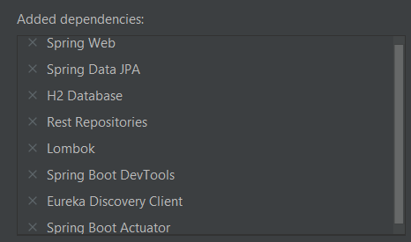

# Fichier application.yml

Using a gateway to access customers

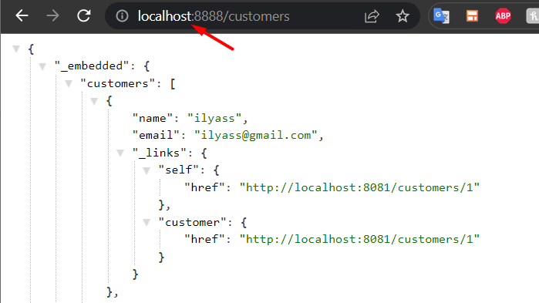

The params

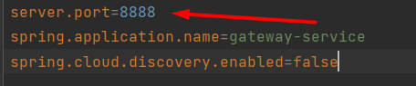

Video 2

Eureka discovery server

Dependencies for billing-service

If the url has /customers it will get the data from localhost:8081

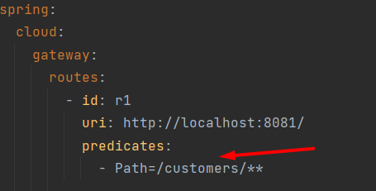

And same for products

We can do this with java too instead of a yml file

# JAVA

It basically does the same thing

Or this instead



To avoid endless loops

We add

Result

Billing service

All:

By id

